**A Novel Approach for optimization of Evaluation Water Quality**

**First author1, Second author2, Third author3 (Times New Roman 11pt)**

1First author affiliation, University/Institute (Times New Roman, 10pt); Email address (9pt)

2Second author affiliation, University/Institute (Times New Roman, 10pt); Email address (9pt)

3Third author affiliation, University/ Institute (Times New Roman, 10pt); Email address (9pt)

* Corresponding author: Name

**Abstract**

The abstract appears before the keywords. Abstract must be about 200 words. However, it must be limited between 150 to 200 words. The abstract should clearly state, the objective, results and the conclusion of the work.

**Keywords:** Up to 6 Words, Separated by Comma.

# Introduction

This instruction gives you guidelines for preparing of papers in 1st National Conference on Environmental Science and Engineering in Future Development. All papers must be submitted electronically in Docx format. Prepare your paper in A4 page size of 210 mm × 297 mm (8.27" × 11.69"). The length of your paper should not exceed 7 pages. Do not include page numbers.

Set the top margin to 1.75" and the bottom margin to 1". Left and right margins should be 1" and gutter 0. Header and footer 0" and 0.5", respectively. Use a single-column format and single spacing.

## Elements of a Paper

The basic elements of a paper are listed below in the order in which they should appear:

* Paper title
* Author names and affiliations
* Abstract
* Keywords
* Introduction
* Main body of paper, including figures and tables, page numbers and footer, headings etc.
* Conclusions
* Acknowledgments
* References

# Prepare your paper before styling

Before you begin to format your paper, first write and save the content as a separate text file. Complete all content and organizational editing before formatting. Please note sections A-D below for more information on proofreading, spelling, and grammar.

Keep your text and graphic files separate until after the text has been formatted and styled. Do not use hard tabs, and limit the use of hard returns to only one return at the end of a paragraph. Do not add any kind of pagination anywhere in the paper. Do not number text heads-the template will do that for you.

# Prepare your paper before styling

The text size of the formula should be similar to the body text size. The formula should be placed in the middle and the serial number on the right. For example:

${IWQI}_{irr}=\sum_{i=1}^{n}{n_{i} w_{i}}$ (1)

Italicize Roman symbols for quantities and variables, but not Greek symbols.

## Figures and Tables

All of the Tables and Figures must be in the center of the page. The title of the Tables must be at the top of the Table and the title of the Figures must be below them at the center. Insert figures and tables after they are cited in the text

Table -Table Type Styles

|  |  |  |  |
| --- | --- | --- | --- |
| Subject | Font | Size | Type |
| Paper Title | Times New Roman | 14 | Bold |
| Name and Family of Authors | Times New Roman | 11 | Bold |
| Affiliation of Authors | Times New Roman | 10 | Normal |
| Section Title | Times New Roman | 12 | Bold |
| Section Subtitle | Times New Roman | 11 | Bold |
| Abstract text | Times New Roman | 11 | Normal |
| Keywords | Times New Roman | 11 | Normal |
| Body text | Times New Roman | 11 | Normal |
| Footnotes | Times New Roman | 9 | Normal |
| Title of Tables and Figures | Times New Roman | 10 | Normal |
| Text of Tables | Times New Roman | 10 | Normal |
| References | Times New Roman | 11 | Normal |

1. Sample of a Table footnote. (*Table footnote*)

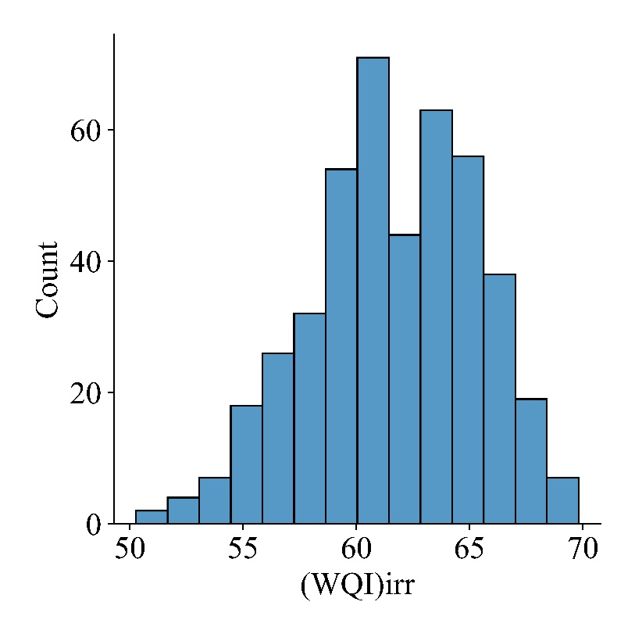

Figure -Figure title

Acknowledgments

Identify grants or other financial support (and the source, if appropriate) for your study (Bhardwaj, Gupta et al. 2015). Thanks to those who helped with the preparation of the article indirectly(Turken and Geda 2020) .

References

All references should be given in the text and provided in APA style (Boyd 2019).

Bhardwaj, J., et al. (2015). A review of emerging trends on water quality measurement sensors. 2015 International Conference on Technologies for Sustainable Development (ICTSD), IEEE.

Boyd, C. E. (2019). Water quality: an introduction, Springer Nature.

Turken, N. and A. Geda (2020). "Supply chain implications of industrial symbiosis: A review and avenues for future research." Resources, Conservation and Recycling **161**: 104974.